**IME PRIIMEK**

**NASLOV**

DOKTORSKA DISERTACIJA

(ZA DELA V ANGLEŠČINI TUDI)

**TITLE**

DOCTORAL DISSERTATION

INTERDISCIPLINARNI DOKTORSKI ŠTUDIJSKI PROGRAM

GRAJENO OKOLJE

Doktorand/ka

**IME PRIIMEK**

**NASLOV**

Doktorska disertacija

**TITLE**

Doctoral dissertation

**Mentor/-ica:** Naziv Ime Priimek, ustanova.

**Somentor/-ica:** Naziv Ime Priimek, ustanova.

**Komisija za spremljanje doktorskega študenta/-tke:**

Naziv Ime Priimek, ustanova (za zunanje člane),

Naziv Ime Priimek, ustanova (za zunanje člane),

Naziv Ime Priimek, ustanova (za zunanje člane),

Naziv Ime Priimek, ustanova (za zunanje člane),

Naziv Ime Priimek, ustanova (za zunanje člane).

Podpisani/-a študent/-ka Ime Priimek, vpisna številka 12345678, avtor/-ica pisnega zaključnega dela študija z naslovom: Naslov zaključnega dela

IZJAVLJAM

1. *Obkrožite eno od variant a) ali b)*

1. da je pisno zaključno delo študija rezultat mojega samostojnega dela;
2. da je pisno zaključno delo študija rezultat lastnega dela več kandidatov in izpolnjuje pogoje, ki jih Statut UL določa za skupna zaključna dela študija ter je v zahtevanem deležu rezultat mojega samostojnega dela;

2. da je tiskana oblika pisnega zaključnega dela študija istovetna elektronski obliki pisnega zaključnega dela študija;

3. da sem pridobil/-a vsa potrebna dovoljenja za uporabo podatkov in avtorskih del v pisnem zaključnem delu študija in jih v pisnem zaključnem delu študija jasno označil/-a;

4. da sem pri pripravi pisnega zaključnega dela študija ravnal/-a v skladu z etičnimi načeli in, kjer je to potrebno, za raziskavo pridobil/-a soglasje etične komisije;

5. soglašam, da se elektronska oblika pisnega zaključnega dela študija uporabi za preverjanje podobnosti vsebine z drugimi deli s programsko opremo za preverjanje podobnosti vsebine, ki je povezana s študijskim informacijskim sistemom članice;

6. da na UL neodplačno, neizključno, prostorsko in časovno neomejeno prenašam pravico shranitve avtorskega dela v elektronski obliki, pravico reproduciranja ter pravico dajanja pisnega zaključnega dela študija na voljo javnosti na svetovnem spletu preko Repozitorija UL;

7. [za zaključna dela na 3. stopnji študija, sestavljena iz člankov] da sem od založnikov, na katere sem predhodno izključno prenesel/-la materialne avtorske pravice na člankih, pridobil/-a potrebna soglasja za vključitev člankov v tiskano in elektronsko obliko disertacije. Soglasja UL omogočajo neodplačno, neizključno, prostorsko in časovno neomejeno hranjenje avtorskega dela v elektronski obliki in reproduciranje ter dajanje disertacije na voljo javnosti na svetovnem spletu preko Repozitorija UL;

8. da dovoljujem objavo svojih osebnih podatkov, ki so navedeni v pisnem zaključnem delu študija in tej izjavi, skupaj z objavo pisnega zaključnega dela študija.

V/Na:

Datum:

Podpis študenta/-ke:

If the thesis is written in English, this page is reserved for a statement in the English language. The statement is available at the end of the study in the VIS online system.

# ERRATA

Page Line Error Correction

# ACKNOWLEDGMENTS

*Acknowledgements are an optional part of the thesis. Their purpose is to acknowledge those who helped in any way with your thesis. Thanks are typically given to the supervisor, co-supervisor, and the institution that may have financially or otherwise supported the study and work. This can be followed by acknowledgements to co-workers or colleagues who have helped with the work or study. Lastly, acknowledgement goes to family and friends.*

# BIBLIOGRAFSKO-DOKUMENTACIJSKA STRAN IN IZVLEČEK

**UDK: XYZ.XZ**

**Avtor:** **Name Surname, standardised scientific or professional title**

**Mentor:** **academic title (shortened) Name Surname, standardised scientific or professional title**

**Somentor:** **academic title (shortened) Name Surname, standardised scientific or professional title**

**Naslov: Title of thesis in Slovenian language**

**Tip dokumenta: doktorska disertacija**

**Obseg in oprema:** **XV, 12 str., 1 pregl., 8 sl., 5 graf., 3 en., 2 pril., 8 virov**

**Ključne besede: up to 10 keywords (in Slovenian language)**

**Izvleček**

The abstract is firstly presented in Slovenian language. If there is no co-supervisor, then the line with the co-supervisor (somentor) can be deleted. An example of academic title (shortened) is prof. Name Surname, Ph.D., but more information can be found in the document “Oblikovanje del na FGG”.

# BIBLIOGRAPHIC-DOCUMENTALISTIC INFORMATION AND ABSTRACT

**UDC: XYZ.XZ**

**Author: Name Surname, standardised scientific or professional title**

**Supervisor:** **academic title (shortened) Name Surname, standardised scientific or professional title**

**Co-supervisor:** **academic title (shortened) Name Surname, standardised scientific or professional title**

**Title: Thesis title in English language**

**Document type: Doctoral Dissertation**

**Notes:** **XV, 12 p., 1 tab., 3 fig., 5 graph., 3 eq., 2 ann., 8 ref.**

**Keywords:** **up to 10 keywords (in English language)**

**Abstract**

Abstract in the English language.

# TABLE OF CONTENT

ERRATA I

ACKNOWLEDGMENTS II

BIBLIOGRAFSKO-DOKUMENTACIJSKA STRAN IN IZVLEČEK III

BIBLIOGRAPHIC-DOCUMENTALISTIC INFORMATION AND ABSTRACT IV

TABLE OF CONTENT V

LIST OF FIGURES VII

KAZALO SLIK VIII

LIST OF TABLES IX

KAZALO PREGLEDNIC X

LIST OF GRAPHS XI

KAZALO GRAFIKONOV XII

OKRAJŠAVE IN SIMBOLI / ABBREVIATIONS AND SYMBOLS XIII

1 FORMATING AND STYLES 1

1.1 Chapter levels 1

1.1.1 Subchapter of third level 1

1.1.1.1 Subchapter at fourth level 1

1.2 Page headers– pagina viva 1

1.2.1 Bachelor thesis 1

1.2.2 Master thesis 2

1.2.3 PhD thesis 3

1.3 Adding intentionally blank pages 3

2 CAPTIONED ELEMENTS 5

2.1 Figure captions 5

2.1.1 Figure editing 5

2.2 Tables 6

2.3 Equations 7

2.4 Numbering and bulleted lists 8

2.5 Referencing numbered elements in the text 9

3 LISTING AND CITING REFERENCES 11

3.1 Referencing from a numbered list – IEEE style 11

3.2 Manual citing from the list of references – CHICAGO style 11

3.3 Automated citing from the list of references 11

4 EXPORTING TO PDF AND SUBMITING THE DOCUMENT 15

4.1 Locking the captioned fields 15

4.2 Difference between printed and electronic version 15

4.3 Exporting to PDF/A format 15

5 REFERENCES (IEEE) 17

6 REFERENCES (Chicago) 18

7 REFERENCES (using Mendeley plug-in) 19

APPENDIX A A-1

APPENDIX B B-1

# LIST OF FIGURES

Figure 1: An example of EMF format of figure. 5

Figure 2: An example of PNG format of the figure. 6

Figure 3: Option of changing table properties. 7

Figure 4: Changing the numbering of equations. 8

Figure 5: Cross-referencing of field Slika 2. 9

Figure 6: Cross-referencing the automatically numbered reference. 11

Figure 7: An option for automatic managing source – Manage Sources. 12

Figure 8: The use of software Mendeley Desktop. 12

Figure 9: The use of the plugin of software Mendeley Desktop in MS Word. 13

Figure 10: Exporting to PDF/A format. 15

# KAZALO SLIK

Slika 1: Primer formata EMF slike. 5

Slika 2: Primer PNG formata slike. 6

Slika 3: Sprememba nastavitev preglednice 7

Slika 4: Spreminjanje številčenja enačb. 8

Slika 5: Sklicevanje na polje Slika 2. 9

Slika 6: Sklicevanje na avtomatsko številčeni vir. 11

Slika 7: Opcija za avtomatsko za urejanje virov - Manage Sources. 12

Slika 8: Uporaba programa Mendeley Desktop. 12

Slika 9: Uporaba vtičnika v MS Word programa Mendeley Desktop. 13

Slika 10: Navodila za izvažanje v PDF/A format. 15

# LIST OF TABLES

Table 1: Example of table. 7

# KAZALO PREGLEDNIC

Preglednica 1: Primer preglednice. 7

# LIST OF GRAPHS

# KAZALO GRAFIKONOV

# OKRAJŠAVE IN SIMBOLI / ABBREVIATIONS AND SYMBOLS

*Here the list of frequently used abbreviations along with their meaning in English and Slovenian language is presented. Detail formatting of this section is left to the author.*

|  |  |
| --- | --- |
| $σ$ | stress - napetost |

|  |  |
| --- | --- |
| DOF | Degree of freedom – prostostna stopnja |
| FEM | Finite Element Method – metoda končnih elementov |
| SDOF | Single degree of freedom – ena prostostna stopnja |

# FORMATING AND STYLES

Any thesis at the Faculty of Civil and Geodetic Engineering, University of Ljubljana should be formatted according to the instructions given in the document:

Koler Povh, T. in Turk, G. 2020. Navodila za oblikovanje visokošolskih del na Fakulteti za gradbeništvo in geodezijo in navajanje virov – dopolnjena izdaja. Ljubljana, Univerza v Ljubljani, Fakulteta za gradbeništvo in geodezijo: 60 str.

Since all the styles are already set (e.g. styles for text, chapters and subchapters, style for spreadsheet and captions, etc.), it is recommended that you write the thesis directly in this template.

The text is written in Times New Roman (or a similar font such as e.g. Garamond, Helvetica can also be chosen). The fot size is 11 pt, and a Line Spacing between 1 and 1.5 should be used. It is recommended that when writing the text, the Style “Besedilo” is selected, which can be modified depending on the choice (e.g. Font or Line Spacing).

For a thesis written by a student at UL NTF, the Page Header must be changed.

## Chapter levels

The individual parts of the thesis should be divided into subchapters, which should be numbered sequentially. The format, style and numbering of the titles should be as presented in this template.

Before the chapter title (i.e. first level chapter), the page break is considered; however, this does not apply to lower levels of chapters. The first level chapter line is always written with capital letters, which is already automatically done in this template. Nevertheless, it is recommended to write the title with a capital letter, as this ensures that all titles will be written the same in the table of contents within the final PDF document.

A blank line must always be placed before and after the chapter title and the subchapters or lower level chapters. In this proposal, this is already considered automatically. Subchapters up to 4th level are included in this template. If necessary, lower-level chapters can also be added.

### Subchapter of third level

#### Subchapter of fourth level

## Page headers– pagina viva

A selection of appropriate page headers is listed for different studies and the bachelor, master, and PhD thesis.

### Bachelor thesis

Priimek, I. 2021. Naslov dela.

Dipl. nal. Ljubljana, UL FGG, Univerzitetni študijski program prve stopnje Gradbeništvo.

Surname, N. 2021. Title.  
BSc Th. Ljubljana, UL FGG, First cycle academic study programme Civil Engineering.

Priimek, I. 2021. Naslov dela.

Dipl. nal. Ljubljana, UL FGG, Univerzitetni študijski program prve stopnje Geodezija in geoinformatika.

Surname, N. 2021. Title.  
BSc Th. Ljubljana, UL FGG, First cycle academic study programme Geodesy and Geoinformation.

Priimek, I. 2021. Naslov dela.

Dipl. nal. Ljubljana, UL FGG, Univerzitetni študijski program prve stopnje Vodarstvo in okoljsko inženirstvo.

Surname, N. 2021. Title.  
BSc Th. Ljubljana, UL FGG, First cycle academic study programme Water Science and Environmental Engineering.

Priimek, I. 2021. Naslov dela.

Dipl. nal. Ljubljana, UL FGG, Visokošolski strokovni študijski program prve stopnje Operativno gradbeništvo.

Surname, N. 2021. Title.  
BSc Th. Ljubljana, UL FGG, First cycle higher education professional study programme Construction Management.

Priimek, I. 2021. Naslov dela.

Dipl. nal. Ljubljana, UL FGG, Visokošolski strokovni študijski program prve stopnje Tehnično upravljanje nepremičnin.

Surname, N. 2021. Title.  
BSc Th. Ljubljana, UL FGG, First cycle higher education professional study programme Technical Real Estate Management.

### Master thesis

Priimek, I. 2021. Naslov dela.

Mag. delo. Ljubljana, UL FGG, Magistrski študijski program druge stopnje Gradbeništvo, Gradbene konstrukcije.

Surname, N. 2020. Title.  
Master Th. Ljubljana, UL FGG, Second cycle master study programme Civil Engineering, Structural Engineering.

Priimek, I. 2021. Naslov dela.

Mag. delo. Ljubljana, UL FGG, Magistrski študijski program druge stopnje Gradbeništvo, Nizke gradnje.

Surname, N. 2021. Title.  
Master Th. Ljubljana, UL FGG, Second cycle master study programme Civil Engineering, Infrastructural Engineering.

Priimek, I. 2021. Naslov dela.

Mag. delo. Ljubljana, UL FGG, Magistrski študijski program druge stopnje Gradbeništvo, Geotehnika-hidrotehnika.

Surname, N. 2021. Title.

Master Th. Ljubljana, UL FGG, Second cycle master study programme Civil Engineering, Geotechnics-Hydrotechnics.

Priimek, I. 2021. Naslov dela.

Mag. delo. Ljubljana, UL FGG, Magistrski študijski program druge stopnje Geodezija in geoinformatika.

Surname, N. 2021. Title.

Master Th. Ljubljana, UL FGG, Second cycle master study programme Geodesy and Geoinformation.

Priimek, I. 2021. Naslov dela.

Mag. delo. Ljubljana, UL FGG, Magistrski študijski program druge stopnje Vodarstvo in okoljsko inženirstvo.

Surname, N. 2021. Title.

Master Th. Ljubljana, UL FGG, Second cycle master study programme Water Science and Environmental Engineering.

Priimek, I. 2021. Naslov dela.

Mag. delo. Ljubljana, UL FGG, Magistrski študijski program druge stopnje Prostorsko načrtovanje.

Surname, N. 2021. Title.

Master Th. Ljubljana, UL FGG, Scond cycle master study programme Spatial Planning.

Priimek, I. 2021. Naslov dela.

Mag. delo. Ljubljana, UL FGG, Magistrski študijski program druge stopnje Stavbarstvo.

Surname, N. 2021. Title.

Master Th. Ljubljana, UL FGG, Second cycle master study programme Buildings.

Priimek, I. 2021. Naslov dela.

Mag. delo. Ljubljana, UL FGG, Magistrski študijski program druge stopnje Informacijsko modeliranje zgradb – BIM A+.

Surname, N. 2021. Title.

Master Th. Ljubljana, UL FGG, Second cycle master study programme Building information modelling – BIM A+.

### PhD thesis

Priimek, I. 2021. Naslov dela.

Dokt. dis. Ljubljana, UL FGG, Interdisciplinarni doktorski študijski program Grajeno okolje – smer Gradbeništvo.

Surname, N. 2021. Title.

PhD Th. Ljubljana, UL FGG, Interdisciplinary doctoral study programme Built Environment – Civil Engineering.

Priimek, I. 2021. Naslov dela.

Dokt. dis. Ljubljana, UL FGG, Interdisciplinarni doktorski študijski program Grajeno okolje – smer Geodezija.

Surname, N. 2021. Title.

PhD Th. Ljubljana, UL FGG, Interdisciplinary doctoral study programme Built Environment – Geodesy.

Priimek, I. 2021. Naslov dela.

Dokt. dis. Ljubljana, UL FGG, Interdisciplinarni doktorski študijski program Grajeno okolje – smer Načrtovanje in urejanje prostora.

Surname, N. 2021. Title.

PhD Th. Ljubljana, UL FGG, Interdisciplinary doctoral study programme Built Environment – Spatial Planning and Spatial Development.

Priimek, I. 2021. Naslov dela.

Dokt. dis. Ljubljana, UL NTF, Interdisciplinarni doktorski študijski program Grajeno okolje – smer Geologija.

Surname, N. 2021. Title.

PhD Th. Ljubljana, UL FGG, Interdisciplinary doctoral study programme Built Environment – Geology.

Priimek, I. 2021. Naslov dela.

Dokt. dis. Ljubljana, UL FGG, Interdisciplinarni doktorski študijski program Varstvo okolja.

Surname, N. 2021. Title.

PhD Th. Ljubljana, UL FGG, Interdisciplinary doctoral study programme Environmental Protection.

## Adding intentionally blank pages

A deliberately blank page labelled »*This page is intentionally blank.«* is added if the next main chapter (first level chapter) does not begin on the odd page. This means a blank page can only be added to even pages. If the chapter ends on an even page, a blank page should not be added. This applies both to the pages in the main part of the document (Arabic page numbers) and in the introductory part of the document (Roman page numbers).

*»This page is intentionally blank.«*

# CAPTIONED ELEMENTS

## Figure captions

Figure captions are usually presented below the figures. The font in the figures may be smaller than in the text, but not smaller than 8 pt. In the case of many images, the numbering may begin with the chapter number, followed by a sequential number of figure in that chapter. Figures should be aligned centred. A minimum figure quality format must be at least 300 DPI. Settings in this template are set to the highest quality of figure storage in the document, which can avoid reducing the size and thus the quality of the images.

The figure and figure caption should be centred, where the figure caption must be below the figure. The title of the figure caption should be followed by a sequential number and the sign “:”. The description of the figure should start with a capital letter and with a final punctuation mark. There should be a blank line between the figure and the text before. Between the figure and the corresponding caption, there should not be any blank lines. The figure caption style is already set in this template under the name Figure (for English caption) and Slika (for Slovenian caption).

If more figures want to be joined, the joined figure should be divided into appropriate parts. These parts must be marked with a sequence of letters and titles of the images.

### Figure editing

For figure editing a remark must be made that the image formats can be divided into raster and vector. The EPS format is very well known among the vector formats, but MS Word no longer supports it. Therefore, we suggest using the EMF format, where when importing an image by right-clicking on the image and then the "Edit Picture" command, the text of the image is additionally edited (Figure 1).



Figure 1: An example of EMF format of figure.

Slika 1: Primer formata EMF slike.

The JPG format is well known among raster formats, which is not recommended due to its lower quality. For these cases, we recommend using the PNG format shown next (Figure 2), or TIFF.

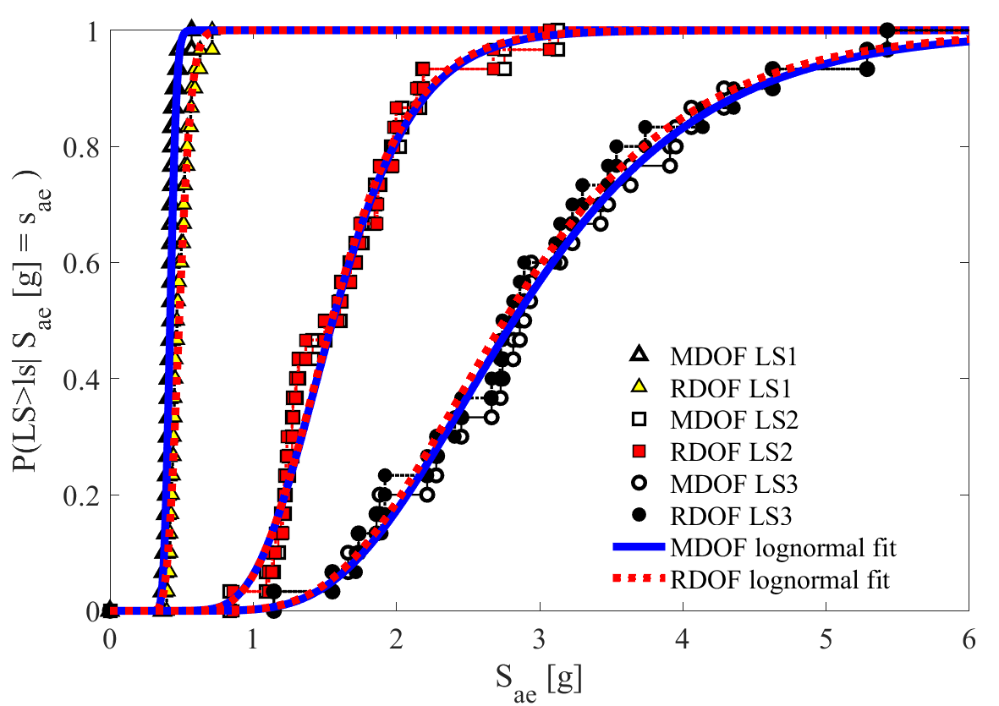

Figure 2: An example of PNG format of the figure.

Slika 2: Primer PNG formata slike.

## Tables

For tables, the table caption is added above them. The font in tables can be smaller than in text but not smaller than 8 pt. If many tables are in a chapter, the table numbering may begin with the chapter number, followed by the table's sequential number. The spreadsheets should be left-aligned.

The title with the sequential number and description should be above the table and left-aligned. After the Table (title) a sequential number is given, which is followed by the sign ":". The table caption must begin with a capital letter and end with a final punctuation mark. Blank line must be added between the text and the table caption. The same goes for the table and the following text. There should be no blank lines between the table caption and the table. The table captions are set under MS Word Styles named Table (for English caption) and Preglednica (for Slovenian text).

It is recommended that the table is located on one page unless it is too large and needs to be divided to multiple pages. This can be arranged automatically by selecting the entire table, and clicking on an arrow pointing diagonally right-down diagonally next to “Paragraph” in the “Home” toolbar, as shown in Figure 3. Then two options should be selected to “Keep with next” and “Keep lines together” so that the table is held together with the following text and that the rows are held together (see Figure 3).

If the table is positioned on more than one page due to its size and position, then below the table on first at the bottom right a text must be added “continued on". At the top left on the next page a text must be added "… continued Table X" and then the table can be continued. An example is given in the document Navodila za oblikovanje visokošolskih del na Fakulteti za gradbeništvo in geodezijo in navajanje virov, from authors Povh, Phd and Turk, Phd.

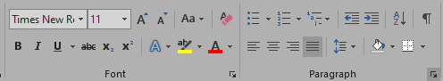

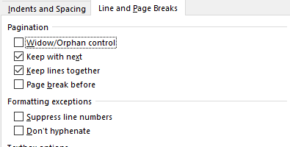

Figure 3: Option of changing table properties.

Slika 3: Sprememba nastavitev preglednice

An example of a table is given bellow (Table 1), where the table design can be changed arbitrarily, for example table border styles, cell sizes, etc.

Table 1: Example of table.

Preglednica 1: Primer preglednice.

|  |  |  |  |  |  |
| --- | --- | --- | --- | --- | --- |
| Formulation | Scheme | $$α_{ED}=0,6$$ | | $$α_{ED}=0,05$$ | |
| Time  CPU | Increment number | Time  CPU | Increment number |
| MITC4 | EDMC1 | 1 | 1340 | 1 | 3250 |
| EDMC2 | 21,07 | 18435 | 8,78 | 31120 |
| MITC4+ | EDMC1 | 0,96 | 1246 | 0,99 | 3206 |
| EDMC2 | 21,95 | 19286 | 10,34 | 37468 |
| EAS5 | EDMC1 | 1,17 | 1328 | 1,12 | 3347 |
| EDMC2 | 21,50 | 18226 | 8,96 | 31155 |
| +HW | EDMC1 | 0,13 | 199 | 0,08 | 350 |
| EDMC2 | 10,06 | 13071 | 5,10 | 20758 |
| +HR | EDMC1 | 0,12 | 199 | 0,07 | 342 |
| EDMC2 | 9,73 | 13346 | 4,95 | 21575 |

## Equations

Numbered or unnumbered equations should all be written in a new line, left aligned with indentation of 1 cm. In case of a numbered equation, the numbering should be written in parentheses and aligned to the right. When the equations are referenced in the text, the reference should also include the parentheses.

Some basic rules regarding equations are given bellow:

* numbers, function, parentheses, units and textual descriptions inside mathematical expressions are all written using non-italic and non-bold letters,
* variables are written using italic symbols from Latin or Greek alphabet,
* matrices and vectors are written using bold, non-italic letters.

|  |  |  |
| --- | --- | --- |
|  | $${\dot{u}}^{\left(i+1\right)}={\dot{u}}^{\left(i+\frac{1}{2}\right)}+\frac{1}{2}Δt^{\left(i+1\right)}{\ddot{u}}^{\left(i+1\right)}$$ | (1) |

In this template, the equations are written inside an invisible table, that gives the equation and its numbering a structure. New equations is thus easily created by copying an existing table that contains the equation (1), or by using the »Insert«, »Equation« command and then choosing the template named »Enačba«.

Currently, the numbering style is set in a way that numbers follow from 1 onwards. If transparency of the document needs to be improved, the numbering can be altered in a way that it includes also the number of chapter it belongs to. Instructions on how to achieve this are given in Figure 4.

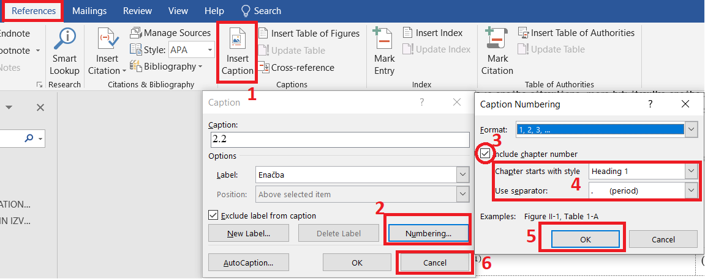

Figure 4: Changing the numbering of equations.

Slika 4: Spreminjanje številčenja enačb.

## Numbering and bulleted lists

In order to achieve a unified look, the same style of bullets should be used for different levels of the lists throughout the text. The look that is proposed in this template is saved in the style »Naštevanje«.

To bullet the text, we use the »-« symbol at the beginning of the line, with a suitable punctuation at the end. An example of a bulleted list is given here:

* example of 1. level:
  + example of 2. level,
* example of 1. level:
  + example of 2. level,
  + example of 2. level.

Between the last line of the list and any new text, there should be an empty line.

## Referencing numbered elements in the text

When referring to a numbered item in this document, it is recommended to do so using the "Cross-reference" function. If you later add new numbered items, rearrange them, or delete any individual entries, the link to the selected item will be maintained and the numbering can be easily updated.

In this template, there are 5 numbered elements that can be used: Enačba, Slika, Figure, Preglednica, Table. Figure 5 shows an example of a reference to a numbered figure, and the same principle applies to any of the listed elements. Using this method, a reference of the form "Figure 5" or “Slika 5” will appear in the text, but the text inside the reference field can be changed at will later. This is especially useful when we want to delete the word "Slika" and write it in the appropriate declension.

When renumbering items, the reference fields need to be updated. This can be done for the entire document at once or for each numbered element and reference separately by highlighting the desired text and selecting the F9 command. Nevertheless, one should keep in mind that updating the field will reverse any changes that were made manually inside the text, such as e.g. changing the word "Slika" to “slika”.

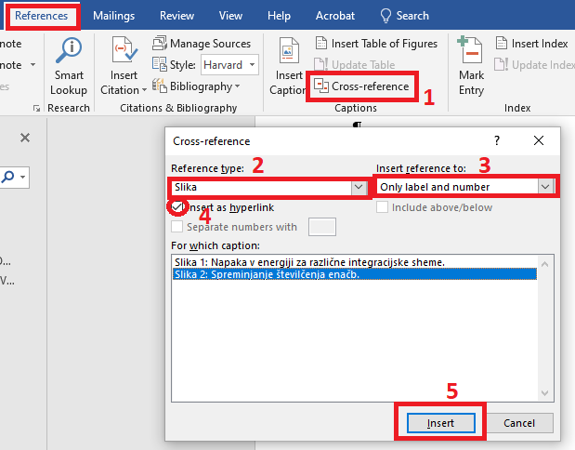

Figure 5: Cross-referencing of field Slika 2.

Slika 5: Sklicevanje na polje Slika 2.

*»This page is intentionally blank.«*

# LISTING AND CITING REFERENCES

In this chapter we show three ways to edit, list and cite references. We leave the choice of a referencing style to each individual.

## Referencing from a numbered list – IEEE style

Let us first present cross-referencing using the numbered list shown in the chapter REFERENCES . Using this system, you can easily add a cross-reference to any individual reference using the function "Cross-reference", where under the "Reference type" you must select "Numbered item" (see Figure 6) and insert reference to “Paragraph number” [1] of any number in the list. When citing several references, comma mark can be used, such as e.g. [2], [3], and hyphens can be used in the case of several consecutive references, such as [4] – [10].

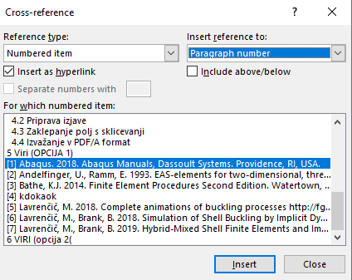

Figure 6: Cross-referencing the automatically numbered reference.

Slika 6: Sklicevanje na avtomatsko številčeni vir.

## Manual citing from the list of references – CHICAGO style

When citing sources manually, one must pay attention to correctly cite sources with one author, e.g. citing Jamšek (2020), or two authors, e.g. Lavrenčič and Brank (2019). In the case of several authors, only the first author is named, while the others are hidden using abbreviation et al., such as Dolšek et al. (2020). Standards are cited by naming the standard and the year of publication as e.g. (SIST EN 1998-1, 2005). Special attention is also needed when referring to any official documents, where the referencing differs slightly, as shown by the example of citing Pravilnik o izdelavi energetskih izkaznic (Uradni list RS št. 92/14 in 47/19).

## Automated citing from the list of references

There are several ways and systems of citing. Citations can be edited manually, or the tool available in MS Word can be used, see Figure 7.



Figure 7: An option for automatic managing source – Manage Sources.

Slika 7: Opcija za avtomatsko za urejanje virov - Manage Sources.

Following these instructions opens a new window where you can add sources as you wish and edit them later. You can choose from several different types of sources and also choose the desired citation style. You can then reference them in the text by selecting the Insert Citation option in the References field in the toolbar. Thus, we can add a reference to the source (Jamšek, 2020). The citation can be further edited by right-clicking on it and choosing which part of the source to specify.

As an alternative, we suggest using one of the plug-ins, such as Zotero, Mendeley or EndNote. In what follows, we show the use of Mendeley plugin, when we have the original files of sources (Lavrenčič and Brank 2018), (Jamšek and Dolšek 2020), (Abaqus 2018), (Andelfinger and Ramm 1993), (Jamšek 2020), (Lavrenčič 2018), (Bathe 1996), on our computer and we added them to the Mendeley Desktop program (Figure 8).

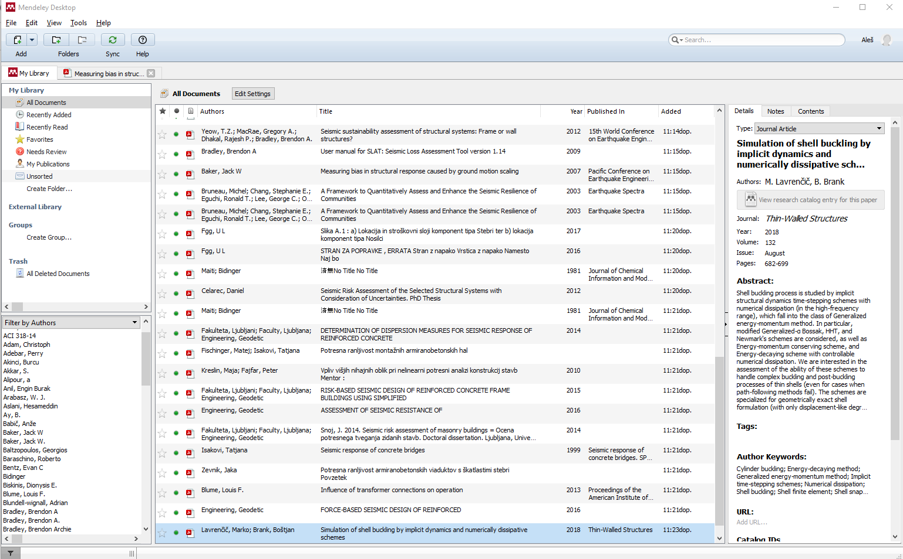

Figure 8: The use of software Mendeley Desktop.

Slika 8: Uporaba programa Mendeley Desktop.

Chicago Manual of Style 17th edition (author-date) style is used in this case and the same option can also be selected in the Zotero software. Other recommended style is also IEEE. We can easily add references in the text, using the collection that we create in the software. Individual citations can be added as shown in Figure 9.

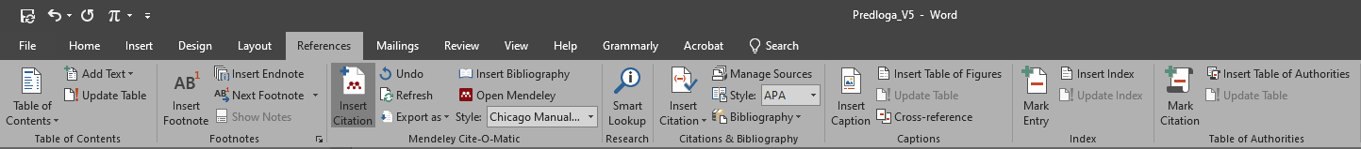

Figure 9: The use of the plugin of software Mendeley Desktop in MS Word.

Slika 9: Uporaba vtičnika v MS Word programa Mendeley Desktop.

*»This page is intentionally blank.«*

# EXPORTING TO PDF AND SUBMITING THE DOCUMENT

## Locking the captioned fields

If you followed the instructions in this document, some reference fields were probably manually modified. MS Word will sometimes update such fields automatically, which means that when exporting to PDF, the entry "glej slika Slika 10" would appear instead of "glej slika 10". This can be avoided by locking all reference fields in the document. First, use the Ctrl + A command to select the entire text in the document, and then use the Ctrl + F11 command to lock all fields. To unlock them again later, use the command Ctrl + Shift + F11. If you wish, you can lock individual fields using the same command already when you are editing the document.

## Difference between printed and electronic version

There should be no differences between the contents of the two document versions. Nevertheless, in order to prepare the electronic version, which will be uploaded to the UL repository, the cover (first page) and the two pages with statements of authorship must be removed from the the document.

## Exporting to PDF/A format

When ready, export the document to PDF / A format by going to "File", "Save As" and then following the instructions in Figure 10. If you followed the instructions correctly, the PDF document will contain all the references that we previously inserted in text.

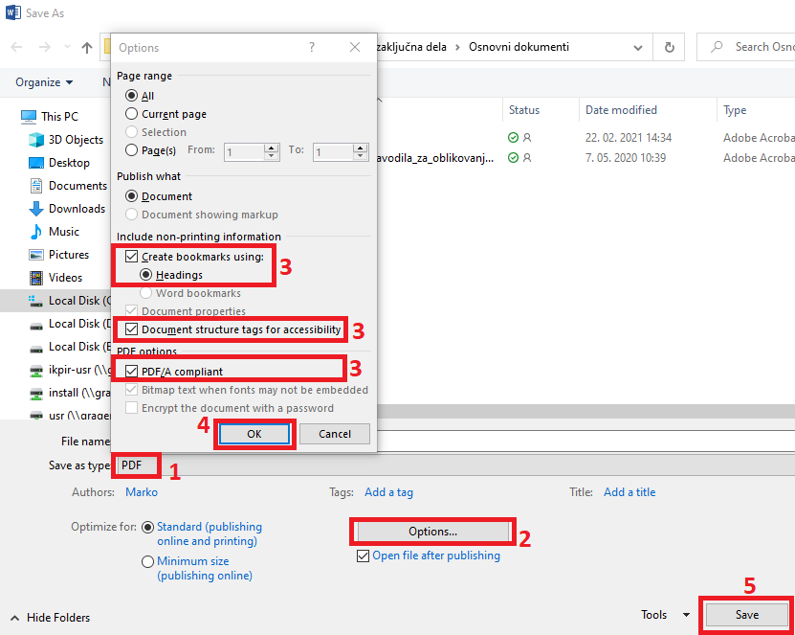

Figure 10: Exporting to PDF/A format.

Slika 10: Navodila za izvažanje v PDF/A format.

*»This page is intentionally blank.«*

# REFERENCES (IEEE)

1. Abaqus. 2018. Abaqus Manuals, Dassoult Systems. Providence, RI, USA.
2. Andelfinger, U., Ramm, E. 1993. EAS-elements for two-dimensional, three-dimensional, plate and shell structures and their equivalence to HR-elements. International Journal of Numerical Methods in Engineering 36: 1311-1337. <https://doi.org/10.1002/nme.1620360805>
3. Bathe, K.J. 2014. Finite Element Procedures Second Edition. Watertown, Massachusetts, (selfpublished by Bathe, K.J.).
4. Jamšek, A. 2020. Seizmični stresni test z nepopolnimi podatki o stavbi. Doktorska disertacija. Ljubljana, Fakulteta za gradbeništvo in geodezijo (samozaložba A. Jamšek): 214 str.
5. Lavrenčič, M. 2018. Complete animations of buckling processes <http://fgg-web.fgg.uni-lj.si/~/mlavrenc/> (Dostopno dne 10. 6. 2020)
6. Lavrenčič, M., Brank, B. 2018. Simulation of Shell Buckling by Implicit Dynamics and Numerically Dissipative Schemes. Thin-walled structures 132: 682-699. <https://doi.org/10.1016/j.tws.2018.08.010>
7. Lavrenčič, M., Brank, B. 2019. Hybrid-Mixed Shell Finite Elements and Implicit Dynamic Schemes for Shell Post-buckling. Altenbach, H. (ed.), Chróścielewski, J. (ed.), Eremeyev, V.A. (ed.), Wiśniewski, K. (ed.) Recent Developments in the Theory of Shells, Springer: 383–412 p.
8. SIST EN 1998-1: 2005 – Evrokod 8: Projektiranje potresnoodpornih konstrukcij – 1. del: Splošna pravila, potresni vplivi in pravila za stavbe.
9. Pravilnik o metodologiji izdelave in izdaji energetskih izkaznic stavb. Uradni list RS št. 92/14 in 47/19 z dne 19.12.2014.
10. Dolšek, M., Žižmond, J., Babič, A., Lazar Sinković, N., Jamšek, A., Gams, M., Isaković, T. 2020. Seizmični stresni test stavbnega fonda Republike Slovenije (2020-2050). Strokovne podlage za pripravo Resolucije o programu krepitve potresne varnosti. Ministrstvo za okolje in prostor, Republika Slovenija (naročnik): 147 str.

# REFERENCES (Chicago)

Abaqus. 2018. Abaqus Manuals, Dassoult Systems. Providence, RI, USA.

Andelfinger, U., Ramm, E. 1993. EAS-elements for two-dimensional, three-dimensional, plate and shell structures and their equivalence to HR-elements. International Journal of Numerical Methods in Engineering 36: 1311-1337. <https://doi.org/10.1002/nme.1620360805>

Bathe, K.J. 2014. Finite Element Procedures Second Edition. Watertown, Massachusetts.

Dolšek, M., Žižmond, J., Babič, A., Lazar Sinković, N., Jamšek, A., Gams, M., Isaković, T. 2020. Seizmični stresni test stavbnega fonda Republike Slovenije (2020-2050), Strokovne podlage za pripravo

Resolucije o programu krepitve potresne varnosti. Ministrstvo za okolje in prostor, Republika Slovenija (naročnik): 147 str.

Jamšek, A. 2020. Seizmični stresni test z nepopolnimi podatki o stavbi. Doktorska disertacija. Ljubljana, Fakulteta za gradbeništvo in geodezijo (samozaložba A. Jamšek): 214 str.

Lavrenčič, M. 2018. Complete animations of buckling processes <http://fgg-web.fgg.uni-lj.si/~/mlavrenc/> (Accessed 10. 6. 2020)

Lavrenčič, M., Brank, B. 2018. Simulation of Shell Buckling by Implicit Dynamics and Numerically Dissipative Schemes. Thin-walled structures 132: 682-699. <https://doi.org/10.1016/j.tws.2018.08.010>

Lavrenčič, M., Brank, B. 2019. Hybrid-Mixed Shell Finite Elements and Implicit Dynamic Schemes for Shell Post-buckling. Altenbach, H. (ed.), Chróścielewski, J. (ed.), Eremeyev, V.A. (ed.), Wiśniewski, K. (ed.) Recent Developments in the Theory of Shells, Springer: 383–412 p.

Pravilnik o metodologiji izdelave in izdaji energetskih izkaznic stavb. Uradni list RS št. 92/14 in 47/19 z dne 19.12.2014.

SIST EN 1998-1: 2005 – Evrokod 8: Projektiranje potresnoodpornih konstrukcij – 1. del: Splošna pravila, potresni vplivi in pravila za stavbe.

# REFERENCES (using Mendeley plug-in)

Abaqus. 2018. “Abaqus Manuals.” Dassoult Systems, Providence, RI.

Andelfinger, U., and E. Ramm. 1993. “EAS-Elements for Two-Dimensional, Three-Dimensional, Plate and Shell Structures and Their Equivalence to HR-Elements.” *International Journal for Numerical Methods in Engineering* 36 (8): 1311–37. https://doi.org/10.1002/nme.1620360805.

Bathe, K. J. 1996. *Finite Element Procedures Second Edition*. *Watertown, Massachusetts*.

Jamšek, A. 2020. “Seizmični Stresni Test z Nepopolnimi Podatki o Stavbi.” *Doktorska Disertacija. Ljubljana, Fakulteta Za Gradbeništvo in Geodezijo (Samozaložba A. Jamšek)*, 214.

Jamšek, A., and M. Dolšek. 2020. “Seismic Analysis of Older and Contemporary Reinforced Concrete Frames with the Improved Fish-Bone Model.” *Engineering Structures* 212 (September 2019): 110514. https://doi.org/10.1016/j.engstruct.2020.110514.

Lavrenčič, M. 2018. “Complete Animations of Buckling Processes.” Http://Fgg-Web.Fgg.Uni-Lj.Si/~/Mlavrenc/. 2018.

Lavrenčič, M., and B. Brank. 2018. “Simulation of Shell Buckling by Implicit Dynamics and Numerically Dissipative Schemes.” *Thin-Walled Structures* 132: 682–99. https://doi.org/10.1016/j.tws.2018.08.010.

*»This page is intentionally blank.«*

###### 

If the doctoral thesis is compiled in the form of a collection of articles, a table should be drawn up following the example below, showing all the articles, the journals in which they were published and whether consent was obtained for the use of the doctoral dissertation article.

|  |  |  |  |  |
| --- | --- | --- | --- | --- |
| **št.** | **Znanstveni članek** | **Revija** | **Dostop** | **Izdajatelj soglasja** |
| 1 | Gašparič, R., Fraaije, R.H.B., Van Bakel, B.W.M., Jagt, J.W.M. & Skupien, P. 2015. Mesozoic Cenozoic crustaceans preserved within echinoid tests and bivalve shells. Bulletin of Geosciences, Vol 90 (3): 601-611. | Bulletin of Geosciences | Licenca odprtega dostopa (Open Access) |  |
| 2 | Gašparič, R., Fraaije, R.H.B., Robin, N. & De Angeli, A. 2016. The first record of paguroids from the Eocene of Istria (Croatia) and further phylogenetic refinement of the Paguroidea (Crustacea, Anomura). Bulletin of Geosciences, Vol 91 (3): 467-480. | Bulletin of Geosciences | Licenca odprtega dostopa (Open Access) |  |
| 3 | Gašparič, R., Audo, D., Hitij, T., Jurkovšek, B. & Kolar-Jurkovšek, T. 2020. One of the oldest polychelidan lobsters from Upper Triassic (Carnian) beds at Kozja dnina in the Julian Alps, Slovenia. Neues Jahrbuch für Geologie und Paläontologie – Abhandlungen, 296/1-2: 107-117. | Neues Jahrbuch für Geologie und Paläontologie |  | Schweizerbart |
| 4 | Hyžný, M., & Gašparič, R. 2014. Ghost shrimp *Calliax* de Saint Laurent, 1973 (Decapoda: Axiidea: Callianassidae) in the fossil record: systematics, palaeoecology and palaeobiogeography. Zootaxa, 3821, 37–57. | Zootaxa |  | Magnolia Press |
| 5 | Hyžný, M., Gašparič, R., Robins, C., Schlögl, J. 2014. Miocene squat lobsters (Decapoda, Anomura, Galatheoidea) of the Central Paratethys – a review, with description of a new species of *Munidopsis*. Scripta Geologica, 147: 241-267. | Scripta Geologica |  | Naturalis |

*» This page is intentionally blank.«*

###### 

*» This page is intentionally blank.«*