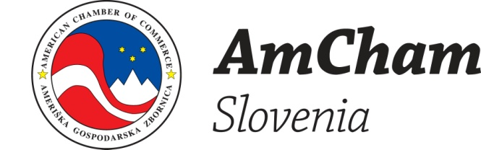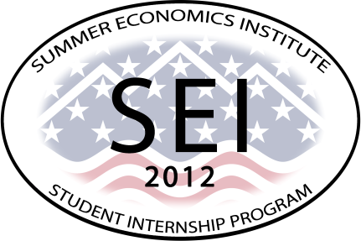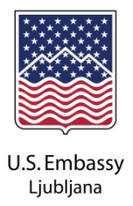

The joint US Embassy – AmCham Slovenia Summer Economics Institute (SEI) is a new paid internship program under the aegis of USA Alumni aimed at giving 20 top 3rd year students from Slovenian universities valuable work experience at American Chamber of Commerce of Slovenia (AmCham Slovenia) member companies, as well as other American companies in Slovenia.
This program will be held from July 2-30, 2012 in Slovenia. SEI will offer 20 top 3rd year students from any faculty in any field of study at a Slovenian university the opportunity to participate in a pilot four-week paid internship program in July 2012 aimed at giving them work experience in companies four days per week, as well as an understanding of basic economics through one day per week of economics coursework taught by US Prof. James Ebben (Professor of Business Administration, St. Thomas University, Minnesota, USA and 2011 US Fulbright Scholar to Slovenia for Entrepreneurship), field trips, and invited speakers. Internships and coursework will take place largely in Ljubljana; more details about the exact program will be available to students once they are accepted to the program.
SEI will give students an introduction to business and economics in the real world. We also hope that this will also give students an understanding of how to apply their knowledge in business and even to creating new businesses – the foundations of business leadership and entrepreneurship.
Who may apply? Potential interns must be 3rd year Slovenian students in good standing at a Slovenian university and may be from any faculty and any field of study. We particularly encourage students from the natural sciences, applied sciences, medicine and engineering to apply.

Applications are available at: http://www.facebook.com/slovenia.usembassy#!/slovenia.usembassy?sk=app_195646697137509

Application due date: March 30, 2012.
Please email your application to Charlotte Taft, US Embassy Ljubljana, email: sei2012slo@gmail.com

Need more information? Charlotte Taft, Alumni Coordinator, Public Affairs Sector, U.S. Embassy Ljubljana, Phone: (386)(0)1 200 5616, Email: TaftCCW@state.gov

